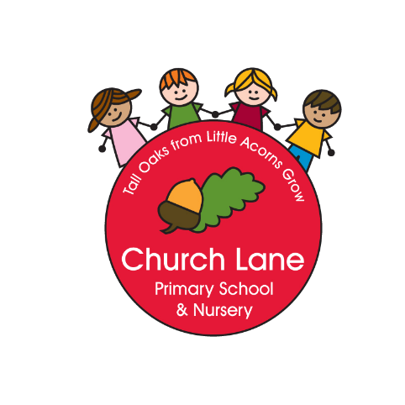

Church Lane Primary School
Ramadan Fasting Policy

Whilst we recognise that fasting is not compulsory before the age of puberty in Islam, we understand that children are often encouraged to fast or indeed wish to fast to prepare them for adulthood.

Aims and Objectives
- To provide a safe environment for children who wish to fast during part or all of the month of Ramadan.
- To ensure the proper care of children is maintained and keep parents informed if their child is unwell.
- To further develop understanding of the different faiths represented in the school population.

Ramadan – An overview
- Ramadan is the ninth month in the Islamic calendar, and it consists of a 29–30 day period of fasting, self-control, charity-giving and goodwill to others.
- Those who fast during Ramadan are not allowed any food or water between sunrise and sunset. Instead, they are encouraged to think of cleansing the whole self, through prayer and reflection.

Implementation

- All parents must inform the school in writing if they wish their child to fast for part or all of the month of Ramadan. We ask that parents complete a ‘fasting permission slip’; these slips are available from the office or can be emailed on request.
- If a child says that they are fasting, but the school has not received a permission slip from their parent, they will be dealt with in a respectful manner; however the child will not be allowed to miss lunch.
- Children who are fasting should not be expected to exert themselves physically.
- For Health and Safety reasons, pupils who are fasting do not do active physical education lessons at the time they are fasting. At this time they will do some health related learning.
- Children who are fasting will not be allowed to participate in rigorous activities such as running around at lunch time. They will be encouraged to make use of quiet areas on the playground or the school library in order to conserve their energy.
- As is the tradition in the school, RE lessons and an assembly will be held during the school year to create an understanding of the Muslim faith and the festival of Eid-ul-Fitr.
- All children that fast will need to bring an emergency snack with them to school daily. This should be something healthy in accordance to our Healthy Eating Policy.
- In the rare circumstances of a child becoming distressed or unwell when he or she is fasting, the school will encourage the child to break their fast by eating their emergency snack and having a drink of water.
- If a child has a medical condition that would be complicated by fasting, e.g. diabetes, the child will not be permitted to fast at school.

Health and Safety
- Parents MUST inform the school via a permission slip if their child is fasting.
- The school will inform parents immediately if their child who is fasting becomes unwell.
- Children who fast must conserve their energy and not join in strenuous games.

Inclusion
- There is mutual co-operation between the parents of children who are fasting and the school.
- All children in the school are encouraged to feel positive about their family, their culture and their faith.

This policy was written by: Callum Clay
It was adopted: March 2020
The policy to be reviewed: March 2024

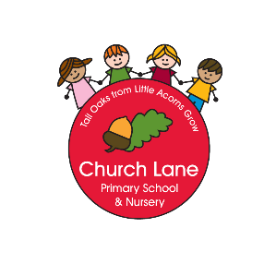
Ramadan Fasting Permission Slip

Child’s Name: ______________________________________
Class: ____________________

✓ I give permission for my child to fast during the period of Ramadan.

✓ I have read the Church Lane Primary School Fasting Policy and understand how the school will implement this.

Signed: ____________________
Print Name: ____________________
Date: ____________________

